Schools’ Report

1. **Summary of the analysis**

The Local Government Area contains fifteen schools and spends approximately $24.5 million on funding. Overall, although greater than 84% of students achieve a pass in maths or reading, the percentage of students achieving passes in both subjects is noticeably lower at 73%., slightly more than a 10% lower.

This pattern is played out in many of the schools, with a noticeably lower proportion of students passing in both subjects. The top five schools in terms of passing both subjects, achieve a rate of 80% (notably lower than the pass rate in either reading or maths). The bottom five schools, in comparison, achieve a rate of between 81 and 82% of students passing one subject, but in terms of passes in both subjects this is considerably lower at approximately 67%.

It is interesting to note that the average maths and reading scores between the top five and bottom five schools are similar, despite the differences in the proportions passing. This indicates that there is more disparity between students within the lowest five schools, which is further evidenced in the lower number of passes achieved in both subjects.

The number of passes in reading in most schools is slightly lower than that in maths, both in terms of the average mark and the proportion of students passing in most of the schools. This is indicative that a greater focus on reading could improve the overall pass rate.

In comparing the level of funding between schools, notably the schools within the bottom two ranges of funding (less than $630 per student) achieve higher results. This is because the independent schools receive lower amounts of funding per student than the government schools. This result has two caveats: firstly, this report is about public funding of schools. Independent schools are likely to have other sources of funding – such as school fees. Secondly, the independent schools are more likely to have students from more advantaged backgrounds and potentially have selective enrolment. Government school are more likely to have a higher proportion of students from lower social-economic backgrounds and will also have pupils with a range of academic abilities. These are factors which greatly affect outcomes, but the data presented in this report does not provide insights into these factors. Similarly the size of school can be correlated with higher scores, with schools under 1,000 getting better results, compared to larger campuses with between 2 - 3,000 pupils. Notably, however, all the schools with less than 2,000 pupils are independent, with the largest school having 2,283 pupils. In comparison all the Government schools have greater than 2,500 pupils. It is therefore not surprising that the comparison between independent and government schools shows that the proportions of pupils passing maths and reading, and passing both, are notably higher; however, it is worth noting that the average scores remain relatively similar, with the gap between independent and government schools being much smaller.

1. **Points of interest**

There is a difference in results between independent and government schools, with independent schools generally having a notably larger proportion of their students achieving passes in either reading or maths, and also in the numbers achieving an overall pass.

Despite there being an overall higher rate of achievement in independent schools compared with government schools, two of the five top-performing schools in terms of overall pass are government schools, whilst there is one independent school in the bottom five. There is disparity in performance between schools, whether independent or government.

A third observation is that there is a clear difference in average scores and proportion of pupils achieving a pass in terms of the size of school. Nonetheless, the largest school, Bailey High School, is the largest school within the data, and it is the third highest ranked in terms of overall passes. It is perhaps noticeable that there is a disparity between the proportions of students gaining passes compared wth a comparison of the average scores by school. This indicates that whereas the government schools are likely to follow a normal distribution, there is a greater skew in the results of the independent schools towards the higher scores. This may be indicative of other factors – such as social-economic background, smaller class sizes and other forms of funding not represented in this data.

5

**3 key findings**

* Theatre is the most frequent category to seek crowdfunding with a total of 344 campaigns, of which 132 were successful. The next largest categories have about 175 campaigns apiece, so ‘Theatre’ is almost twice as frequent within this data. It is interesting to note that next largest categories are ‘Film & Video’ and ‘Music’ which are also concerned with performing arts. It would be interesting to investigate this further – for instance, are these projects driven to crowdfunding because traditional funding sources harder for these industries to access, or does it reflect the preference of people who access crowdfunding platforms?

***Number of projects by category and outcome.***

* Projects with goals valued between 1,000 and 10,000, represent 55% of the total sample. Projects greater than this have a higher success rate, but this is based on a very small number of projects and is not a reliable indicator: projects falling between 10,000 and 50,000 represent only 8% of the total.

The most successful group of projects by funding size are those with goals between $1,000 and $5,000 and enjoy a success rate of 83%. This group represents 23% of the total dataset, and we can have confidence in this result.

The grouping of projects between 5,000 and 10,000 represent the largest group, with 31% of total projects, but have a lower success rate of 52%.

Whilst the numbers of projects with more ambitious goals are very small, the number of the of projects seeking greater than 50,000 represents 305 projects. Clearly, this will include a large range of project values, including high value outliers, but tellingly only 37% of this group were successful.

We can conclude that crowdfunding works particularly well for smaller projects. This perhaps reflects that these projects need far fewer backers to achieve success. It would be interesting to research this further as the implications for campaigns positioning themselves for success could be profound.

***Percentage of outcomes based on value of goal***

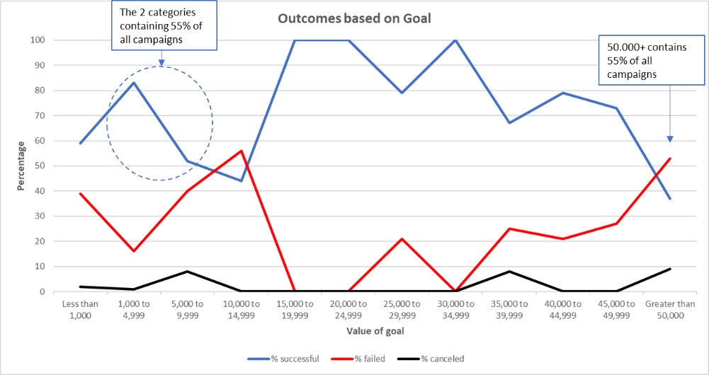

1. **What are some limitations of this dataset?**

* The sample is heavily influenced by US projects, which represent 76% of the data. This distorts the picture it gives for the other countries profiled. We can only make sound conclusions about the US market given the relatively small samples from the other countries listed.

***US projects by category as a proportion of total***



* All the other countries within the dataset are from the west: Australia, Switzerland, Italy, Canada, Denmark, and the UK. The market for crowdfunding is far wider. Although the US represents by far the largest market, countries such as China, Russia, India, Korea and Japan also have a large number of crowdfunded projects and crowdfunding platforms. Given that these countries are culturally diverse from those contained within the sample dataset, any conclusions drawn cannot be confidently applied to those markets.
* We do not know which crowdfunding platforms have provided this data. This would be essential as the choice of platform may influence the success of a crowdfunding project or may prove more suitable to a particular category. The data may have been sourced from a popular crowdfunding platform that attracts a high number of people interested in the arts, but if you are raising money for a technological or environmental project there may be more suitable platforms to attract backers.
* The analysis does not distinguish between currencies in the values of pledges offered, and there is no conversion into one currency for purposes of comparison. This presents a potentially distortion to any analysis around correlations between values of goals and outcomes. Although the distortion might be less in lower value ranges, the difference between values will have an increasing effect on the higher ranges. The conversion rate between UK Stirling and US dollars would mean that campaigns valued at $15,000 (US) would be misclassified in a higher value group (on the scale adopted in this analysis) than a UK project also worth $15,000 (US) – roughly £12,600.
* There is a huge variance in the number of projects by category. Excluding the categories that address the performing arts, the number of projects within other categories are considerably smaller. Journalism has a 100% success rate, but there are only four projects, meaning that no conclusions can be drawn. If we take the number of projects desirable to allow meaningful analysis as 50 (albeit an arbitrary threshold), then only four of the nine categories qualify.
* When the categories are broken down into subcategories, then the issue is even more prevalent, and most subgroups give too small a sample of projects to provide meaningful analysis. The only subcategories with samples of greater than 50 projects are Plays (synonymous with its parent category ‘Theatre’), Rock, Documentary and Web. A larger dataset would be needed to drill down meaningfully into subcategories. Subcategories

1. **What are some other possible tables and/or graphs that we could create, and what additional value would they provide?**
   * A table and graph showing the range of average pledges per backer, and potentially by category. An idea about the range of what people are likely to contribute would inform us as to whether certain categories of project attract higher pledges compared to others. If this were the case then additional research could be undertaken as to whether certain categories appeal to wealthier social groups, whether projects are gaining higher pledges because they appeal to a devoted audience or have easy access likely backers (such as a podcast appealing to its listeners to pledge).

Knowing the typical size of pledge by category would also enable a potential project to evaluate how many backers it is likely to need to achieve success and what resources it would need to dedicate to achieve success.

* + Whether there is a correlation between success and the duration of a campaign. We could evaluate whether most successful campaigns reach their target over a shorter or longer space of time. This could mean that campaigns seeking funding will know the most critical period to promote their campaigns, and how long a campaign should run before the risk of failure outweighs the cost of continued promotion.